20/11/2017



**Functional Document**

**Safe and Independent living for elderly people. (Ambient Assisted Living)**

**Student Name: Frank Rooney**

**Student ID: C00196890**

**Supervisor: Hisain​ ​Elshaafi**

Contents

Abstract 2

Introduction 2

Concept of project 2

Target Market 2

User Groups 2

Use Case Diagram 3

Brief Use Cases 4

Supplementary Specification 8

Usability 8

Reliability 8

Performance 8

Supportability 8

Metrics 8

Objective 8

Aim 8

Goal 8

Inspiration 9

How does it differ? 9

# Abstract

The purpose of this document is to outline the functional and non-functional to be developed for this project. The key functionality will be described for all system operations. This functional document describes each system component using detailed use cases and a system architecture overview.

# Introduction

## Concept of project

The concept of this project is to develop responsive web application for use on tablet, desktop or mobile which will incorporate a recall of memories activity to enhance the lives of those suffering from early stage Alzheimer’s.

The application activity will consist of images loaded onto the system by a family member or carer along with a set of predefined questions and answers directly related to the loaded images. The questions will be designed in such a way that the user will be given an image and a question with three possible answers, one of which is correct. The answers will then be displayed at the end and will be scored on each level.

The data gathered from the answers will be stored in a database which can be reproduced in chart form for analysis of the users progress or decline. The levels can be set by the administrator (family member or carer) these images may be old photos or current trips which can be uploaded via wireless connectivity directly from camera or via the tablet itself.

The database used for the application will be a cloud-hosted database in Realtime. Data is stored as JSON and synced to every connected client. This mean the application can be deployed for both iOS and Android using only one code base called Ionic as outline in research document.

# Target Market

## User Groups

Elderly Person This will be the main end user. The application will focus on this segment because the aim of the project is to add a better quality of life to Alzheimer’s or dementia sufferers.

Carer. A volunteer of paid professional who looks after an elderly of sick patient who cannot survive independently This application can be viewed as an aid to the carer.

Family Members Other members or relations of the Elderly person. The app can be a collaboration tool for family members who cannot get to see their love ones as often as they would like.

# Use Case Diagram

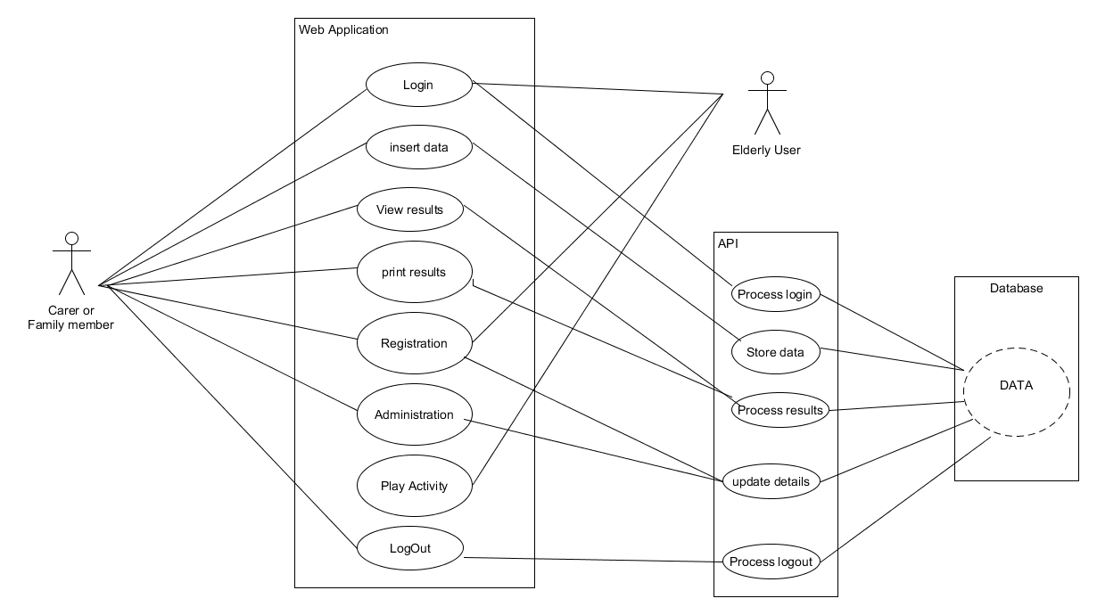Actors: Carer, Family Member, Elderly User, API, Database

For the brief use cases Family member and carer will be denoted as Admin.

# Brief Use Cases

|  |  |
| --- | --- |
| Name | Login User |
| Actors | User, Web app, API |
| Summary | User wishes to use the application |
| Description | This case begins when a user requires access to the System. The system will receive a request from the server to fill in the username and password. For ease of use there will be a remember me cookie to allow for better user experience. The server will then validate the request with the data base. The case will end when the validation is successful, and the user has logged on. |
| Result | User has successfully logged in |

|  |  |
| --- | --- |
| Name | Insert Data |
| Actors | Admin, Web App, API, Database |
| Summary | Admin wishes to upload data to database |
| Description | The Administrator is already logged in. They will be presented a list of Admin functions. From list select insert data. Firstly, a connection must be made to the database. An insert prompt will display a message with an option to insert images or text. Once an option is selected it will now allow user to upload images followed by questions and answers. Execute the insert command and insert to database. Success message then displayed |
| Result | The items have been inserted to database successfully |

|  |  |
| --- | --- |
| Name | View Results |
| Actors | Admin, Web App, API, Database |
| Summary | Admin wish to view progress results of user |
| Description | The Administrator is already logged in. They will be presented a list of Admin functions. From list select view results. A further list will be displayed on screen which will allow the admin user to select different results types by filling in some data range fields and press view. The selected results will now be displayed on screen. |
| Result | Required results are displayed correctly on screen |

|  |  |
| --- | --- |
| Name | Print Results |
| Actors | Admin, Web App, API, Database |
| Summary | Admin wish to print progress results of user |
| Description | The Administrator is already logged in. They will be presented a list of Admin functions. From list select view results. A further list will be displayed on screen which will allow the admin user to select different results types by filling in some data range fields and press the print option. The selected results will now be printed. |
| Result | Required results have printed successfully |

|  |  |
| --- | --- |
| Name | Registration |
| Actors | Admin User, User Web app, API, Database |
| Summary | Create a user |
| Description | Any user wishing to the app must find domain name and a landing page will be displayed with a list of options. Login or create account. If registering new account, the user will be presented with a form to fill in the details of Name, address, email etc. Then they must fill in password and confirm. His or her information is now stored in database. A request to login is now displayed on screen. Once filled in and login button pressed. The credentials are validated against the database and access is granted |
| Result | User has successfully registered |

|  |  |
| --- | --- |
| Name | Log in Admin |
| Actors | Admin, Web app, API, Database |
| Summary | Admin User wishes to use the application |
| Description | This case begins when a admin user requires access to the System. The system will receive a request from the server to fill in the username and password. For security reasons Admin users will not have a remember me cookie and must login with username and password always. The server will then validate the request with the data base. The case will end when the validation is successful, and the Admin user has logged on. |
| Result | Admin User has successfully logged in |

|  |  |
| --- | --- |
| Name | Play Activity |
| Actors | User Database web app |
| Summary | User wishes to play activity |
| Description | The User is already logged In. Displayed on the navigation bar of the home screen the will be an activity tab. The user must select this. Once selected the activity will load and two options buttons will be displayed. Start and Quit. They user selects start and the activity begins. |
| Result | The activity has successfully started |

|  |  |
| --- | --- |
| Name | Log out |
| Actors | User, Database, web app |
| Summary | The user wishes to log out of the Web Application |
| Description | There is a remember me cookie on registration to make the user experience easier. IF the User wishes to log out of the application. The user must navigate back to home screen there they will find a log out button. The user selects the button. A message box will display a confirmation message (Are you sure you want to log out Yes/NO the credentials are verified against the database and the session is terminated a valid response is returned |
| Result | The user has successfully logged out |

|  |  |
| --- | --- |
| Name | Log out Admin |
| Actors | Admin, Database, web app |
| Summary | The Administrator wishes to log out of the Web Application |
| Description | The Administrator wishes to log out of the application. He or she are presented with a tab within the administration home Page. The Administrator selects the admin tab from the Navigation bar and then selects log out tab. A message box will display a confirmation message (Are you sure you want to log out Yes/NO the credentials are verified against the database and the session is terminated a valid response is returned |
| Result | The admin user has successfully logged out |

|  |  |
| --- | --- |
| Name | Administration |
| Actors | Admin, API, Web app, Database |
| Summary | Admin user wishes to update database |
| Description | The Admin user is already logged in. Displayed on the navigation bar on the admin user home page is the administration tab. when selected this will display a list of option for updating the details of users. Then admin user can update create and delete any detail from here. Once the correct details have been altered the user will be shown and alert box asking to confirm the changes. If confirm the selected details will be updated. |
| Result | Data has been successfully updated |

Supplementary Specification  
  
Functionality  
The database on the server should support data stored and data output for the user.  
The server should be able to determine the identity of the user from a local host computer.

Usability  
The application design must be able to accommodate a variety of browsers.

Reliability  
Failure avoidance, if offline the system data must be stored and upload when session is resumed.  
Disk backup of system data to safe guard for system failure.

Performance   
The application should not be slower than the hardware allows.

Supportability  
Enough licences to allow for expansion  
Encryption methods applied to safeguard user sensitive data   
Password login for all users to promote security and add customer value.  
Allow for expansion within design to allow for additional functions in the future.

# Metrics

## Objective

To design and create a web application that will incorporate the use of images and questions to assist the ever-increasing population of elderly suffering from dementia and Alzheimer’s disease. The purpose of the application is to take everyday old and new photographs and arrange with associated questions in the form of an interactive game.

## Aim

The application should allow the carer or family member to upload images and compile questions to the application from a laptop, desktop or mobile device quickly and easily. These should then be available later in a game format to the elderly user. The user interface should be designed in such a way to make the experience user friendly for the elderly.

## Goal

The create a working web application that will have all the design features and attributes stated above that will enhance the lives of its users and help slow the process of Alzheimer’s and dementia.

# Inspiration

The decision to create an application of this kind was an easy one for me. My father in-law has been suffering from Alzheimer’s disease now for the past five years.

I remember the day well when my wife and I discovered there was something wrong. We were visiting her father as we always did every evening after work. He lived alone a widower of some twenty years. He would have been a very healthy clever man of 87 years. He was a self-taught artist and was an excellent wood turner too.

He told us he was in a dark place and could not find away out. It broke my heart to see such a great man and best friend change so drastically. We immediately packed up his stuff and brought him to live with us and he is still there to this day.

On diagnoses the doctors prescribed medication which only made him sedated and more distant. So, after consulting his doctor we decided to take our chances and stop the meds. We discovered of time that the constant interaction with us and our friends has helped him live a somewhat good life.

From my experience first-hand at the effect of this stimulation has done for Steve, I felt it would be a great opportunity to use what I have learned from him combined with what I have studied for in college and create something that might help others in a similar situation.

# How does it differ?

There are many applications for Alzheimer’s and dementia. They all have similar functionality and are geared towards brain training and cognitive assessment through a series of games. Through the research I found one app which I found to be like the App I propose to build. “MindMate”. As previously depicted in the research document the aim is to assist in having fun while keeping the user independent for as long as possible. Reminders to take pills, brush teeth and more importantly to eat. This is also an aide to family and carers alike.

Where this app will be using images as the focus of the application to build story lines preserve memories.

Although these apps are geared towards helping people remember I believe there is gap in this area of elderly people where they are isolated or alone. Possibly in a care home and don’t get to see their families too often. These is a need for an application to just share an old memory, family photos or easy way to connect to a loved one to break the cycle of loneliness. Some elderly people may not be able to use a brain quiz simply because they are too old.

The application will be focus toward a more keeping in touch with loved ones and friends while also stimulating cognitive abilities. Given a sense of belonging again. Mindmate is not available for android now but is in development. Were as this application will be available as a web app to be accessed on any device.